**A PROJECT REPORT**

**ON**

**E-Learning Platform**

**Submitted By:**

Rajalakshmi R

B.E, IIIrd year CSE,

Velammal Institute of Technology,

Chennai.

**Date:** 12 February 2023.

ABSTRACT:

The purpose of E-learning System is to automate the existing manual system by the help of computerized equipment's and full-fledged computer software, fulfilling their requirements, so that their valuable data/information can be stored for a longer period with easy accessing and manipulation of the same. The required software and hardware are easily available and easy to work with. E-learning System, as described above, can lead to error free, secure, reliable and fast system.

It can assist the user to concentrate on their other activities rather to concentrate on the record keeping. Thus, it will help organization in better utilization of resources. The organization can maintain computerized records without redundant entries. That means that one need not be distracted by information that is not relevant, while being able to reach the information.

**What is E-Learning platform?**

An online learning platform is a webspace or portal for educational content and resources that offers a student everything they need in one place: lectures, resources, opportunities to meet and chat with other students, and more. It is also an excellent way for the student and the teacher to monitor student progress.

Online Learning offers a wide range of benefits:

* The comfort of working from home
* Self-paced learning
* Improved technical, communication, and critical thinking skills
* Lower costs
* Better time management skills and more

**CODES:**

**login.html**

<!DOCTYPE html>

<html>

<head>

<link rel="shortcut icon" type="png" href="images/elogo.png">

<title>Login SignUp</title>

<link rel="stylesheet" type="text/css" href="loginStyle.css">

<!-- It will redirect to the Home Page after submitting the form -->

<script>

$(document).ready(function(){

$("form").submit(function(){

alert("Great Job !");

});

});

</script>

</head>

<body>

<div class="form-box">

<div class="button-box">

<div id="btn"></div>

<button type="button" class="toggle-btn" id="log" onclick="login()" style="color: rgb(0, 6, 0);">Log In</button>

<button type="button" class="toggle-btn" id="reg" onclick="register()">Register</button>

</div>

<div class="social-icons">

<img src="images/fb2.png">

<img src="images/insta2.png">

<img src="images/tt2.png">

</div>

<!-- Login Form -->

<form id="login" class="input-group" action="index.html">

<div class="inp">

<img src="images/user (1).png"><input type="text" id="email" class="input-field" placeholder="Username or Phone Number" style="width: 88%; border:none;" required="required">

</div>

<div class="inp">

<img src="images/password (1).png"><input type="password" id="password" class="input-field" placeholder="Password" style="width: 88%; border: none;" required="required">

</div>

<input type="checkbox" class="check-box">Remember Password

<button type="submit" class="submit-btn">Log In</button>

</form>

<div class="other" id="other">

<div class="instead">

<h3>or</h3>

</div>

<button class="connect" onclick="google()">

<img src="images/google.png"><span>Sign in with Google</span>

</button>

</div>

<!-- Registration Form -->

<form id="register" class="input-group">

<input type="text" class="input-field" placeholder="Full Name" required="required">

<input type="email" class="input-field" placeholder="Email Address" required="required">

<input type="password" class="input-field" placeholder="Create Password" name="psame" required="required">

<input type="password" class="input-field" placeholder="Confirm Password" name="psame" required="required">

<input type="checkbox" class="check-box" id="chkAgree" onclick="goFurther()">I agree to the Terms & Conditions

<button type="submit" id="btnSubmit" class="submit-btn reg-btn">Register</button>

</form>

</div>

<script type="text/javascript" src="script.js"></script>

</body>

</html>

**Index.html**

<!DOCTYPE html>

<html>

<head>

<link rel="shortcut icon" type="png" href="images/elogo.png">

<meta charset="utf-8">

<meta http-equiv="X-UA-Comaptible" content="IE=edge">

<title>E-Learn</title>

<meta name="desciption" content="">

<meta name="viewport" content="width=device-width, initial-scale=1">

<link rel="stylesheet" type="text/css" href="style.css">

<script type="text/javascript" src="script.js"></script>

<script src="https://code.jquery.com/jquery-3.2.1.js"></script>

<script>

$(window).on('scroll', function(){

if($(window).scrollTop()){

$('nav').addClass('black');

}else {

$('nav').removeClass('black');

}

})

</script>

</head>

<body>

<!-- Navigation Bar -->

<header id="header">

<nav>

<div class="logo"><img src="images/elogo.png" alt="logo"></div>

<ul>

<li><a class="active" href="">Home</a></li>

<li><a href="#courses_section">Courses</a></li>

<li><a href="#about_section">About</a></li>

<li><a href="#services_section">Services</a></li>

<li><a href="#contactus_section">Contact</a></li>

</ul>

<div class="srch"><input type="text" class="search" placeholder="Search here..."><img src="images/search.png" alt="search" onclick=slide()></div>

<a class="get-started" href="login.html">Get Started</a>

</nav>

<div class="head-container">

<div class="quote">

<p>E-LEARN</p>

<h5><br>A learning system based on formalised teaching but with the help of electronic resources is known as E-learning

While teaching can be based in or out of the classrooms, the use of computers and the Internet forms the major component of E-learning.

E-learning can also be termed as a network enabled transfer of skills and knowledge,

and the delivery of education is made to a large number of recipients at the same or different times. Earlier,

it was not accepted wholeheartedly as it was assumed that this system lacked the human element required in learning.</h5>

</div>

</header>

<!-- Some Popular Courses-->

<div class="diffSection" id="courses_section">

<center><p style="font-size: 50px; padding: 55px">Courses</p></center>

<center><p>Course is a unit of teaching that typically lasts one academic term.<br> These are the courses offered by E-learn:</p></center>

<br><br>

<div class="course">

<center><div class="cbox">

<div class="det"><a href="courses.html"><img src="images/courses.jfif">Courses</a></div>

<ul>

<li> C Programming</li>

<li> Java Programming</li>

<li> Data Science</li>

<li> Artificial Intelligence</li>

<li> Database management system</li>

<li> Python</li>

<li> Data Structures</li>

<li> Materials</li>

</ul>

</div>

</div>

<!-- ABOUT -->

<div class="diffSection" id="about_section">

<center><p style="font-size: 50px; padding:50px">About</p></center>

<div class="about-content">

<div class="side-image">

<img class="sideImage" src="images/about.jfif">

</div>

<div class="side-text">

<h2>Languages used in E-Learn</h2>

<p>Using HTML(HyperText Markup Language), CSS(Cascading Style Sheet), JavaScript.<br> The HyperText Markup Language or HTML is the standard markup language for documents designed to be displayed in a web browser. It can be assisted by technologies such as Cascading Style Sheets (CSS) and scripting languages such as JavaScript.<br>Cascading Style Sheets (CSS) is a style sheet language used for describing the presentation of a document written in a markup language such as HTML or XML. CSS is a cornerstone technology of the World Wide Web, alongside HTML and JavaScript.</p>

</div>

</div>

</div>

<!-- SERVICES -->

<div class="service-swipe">

<div class="diffSection" id="services_section">

<center><p style="font-size: 50px; padding: 100px; padding-bottom: 40px; color: #fff;">Services</p></center>

</div>

<a href="courses.html"><div class="s-card"><img src="images/onlinecourse.png"><p>Free Online Computer Courses</p></div></a>

<a href="courses.html/#cprg"><div class="s-card"><img src="images/videolec.jfif"><p>Online Video Lectures</p></div></a>

<a href="courses.html/#sample_papers"><div class="s-card"><img src="images/bookmat.png"><p>Materials</p></div></a>

<a href="#contactus_section"><div class="s-card"><img src="images/service.png"><p>24x7 Online Support</p></div></a>

</div>

<!-- CONTACT US -->

<div class="diffSection" id="contactus_section">

<center><p style="font-size: 50px; padding: 100px">Contact Us</p></center>

<div class="csec"></div>

<div class="back-contact">

<div class="cc">

<form action="mailto:rajirohith28@gmail.com.com" method="post" enctype="text/plain">

<label>First Name <span class="imp">*</span></label><label style="margin-left: 185px">Last Name <span class="imp">*</span></label><br>

<center>

<input type="text" name="" style="margin-right: 10px; width: 175px" required="required"><input type="text" name="lname" style="width: 175px" required="required"><br>

</center>

<label>Email <span class="imp">*</span></label><br>

<input type="email" name="mail" style="width: 100%" required="required"><br>

<label>Message <span class="imp">*</span></label><br>

<input type="text" name="message" style="width: 100%" required="required"><br>

<label>Additional Details</label><br>

<textarea name="addtional"></textarea><br>

<button type="submit" id="csubmit">Send Message</button>

</form>

</div>

</div>

</div>

</body>

</html>

**Courses.html**

<!DOCTYPE html>

<html>

<head>

<link rel="shortcut icon" type="png" href="images/elogo.png">

<title></title>

<link rel="stylesheet" type="text/css" href="subjects.css">

<script type="text/javascript" src="../script.js"></script>

</head>

<body>

<!-- NAVIGATION -->

<header>

<div class="nav" id="nav">

<div id="learned-logo">

<a href="index.html"><img src="images/elogo.png" style="width: 120px;"></a></div>

<div class="switch-tab" id="switch-tab" onclick="switchTAB()"><img src="images/e-learn.png"></div>

<ul>

<li><a href="#basic">Basics</a></li>

<li><a href="#course">Courses</a></li>

</ul>

<div class="search" id="search-switch">

<input type="text" placeholder="Search" class="srch"><button id="srchbtn"><img src="images/search (1).png"></button>

</div>

</div>

</header>

<div class="title">

<span>Courses on E-Learn</span>

<div class="shortdesc">

<p>E-Learn is a learning platform used mainly for gaining knowledge about computer programming languages <br>and some of the important recent technologies.<br>

E-Learn also provides study material for each concepts.</p>

<span>Basic Concepts</span>

<p>Some of the basic concepts are added below for your reference.</p>

</div>

</div>

<!-- Quick Links -->

<div class="course" id="basic">

<div class="cbox">

<div class="det"><a href="https://en.wikipedia.org/wiki/Data_(computer_science)" target="_blank">Data</a></div>

<div class="det"><a href="https://en.wikipedia.org/wiki/Information#" target="_blank">Information</a></div>

<div class="det"><a href="https://www.knowledgehut.com/blog/database/tuple-in-dbms" target="_blank">Tuple</a></div>

<div class="det"><a href="https://en.wikipedia.org/wiki/Function_(computer_programming)" target="_blank">Functions</a></div>

<div class="det"><a href="https://en.wikipedia.org/wiki/Relation_(database)" target="_blank">Relations</a></div>

<div class="det"><a href="https://www.geeksforgeeks.org/what-is-array/" target="_blank">Array</a></div>

<div class="det"><a href="https://en.wikipedia.org/wiki/String_(computer_science)" target="_blank">String</a></div>

<div class="det"><a href="https://www.webopedia.com/definitions/keyword/" target="_blank">Keyword</a></div>

</div>

<div class="cbox">

<div class="det"><a href="https://en.wikipedia.org/wiki/Python_(programming_language)">Python</a></div>

<div class="det"><a href="https://en.wikipedia.org/wiki/Operator_(computer_programming)" target="_blank">Operator</a></div>

<div class="det"><a href="https://en.wikipedia.org/wiki/Inheritance_(object-oriented_programming)" target="_blank">Inheritance</a></div>

<div class="det"><a href="https://www.knowledgehut.com/blog/database/entity-in-dbms">Entity</a></div>

<div class="det"><a href="https://en.wikipedia.org/wiki/Polymorphism_(computer_science)">Polymorphism</a></div>

<div class="det"><a href="https://en.wikipedia.org/wiki/Abstraction_(computer_science)" target="_blank">Abstraction</a></div>

<div class="det"><a href="https://en.wikipedia.org/wiki/Data_structure" target="_blank">Data Structures</a></div>

</div>

<div class="inbt">

Develope our technical knowledge using these easily understandable videos.

</div>

<!-- COURSES AVAILABLE -->

<div class="ccard" id="course">

<center>

<div class="ccardbox">

<div class="dcard">

<div class="fpart"><img src="images/c prg.jfif"></div>

<a href="#cprg"><div class="spart"> Course <img src="images/dropdown.png"></div></a>

</div>

<div class="dcard">

<div class="fpart"><img src="images/java.png"></div>

<a href="#java"><div class="spart"> Course <img src="images/dropdown.png"></div></a>

</div>

<div class="dcard">

<div class="fpart"><img src="images/datasci.png"></div>

<a href="#datasci"><div class="spart"> Course <img src="images/dropdown.png"></div></a>

</div>

</div>

<div class="ccardbox">

<div class="dcard">

<div class="fpart"><img src="images/ai.jfif"></div>

<a href="#ai"><div class="spart"> Course <img src="images/dropdown.png"></div></a>

</div>

<div class="dcard">

<div class="fpart"><img src="images/dbms.jfif"></div>

<a href="#dbms"><div class="spart">Course <img src="images/dropdown.png"></div></a>

</div>

<div class="dcard">

<div class="fpart"><img src="images/ds.jfif"></div>

<a href="#ds"><div class="spart"> Course <img src="images/dropdown.png"></div></a>

</div>

</div>

</div>

<div class="ccardbox">

<div class="dcard">

<div class="fpart"><img src="images/python.jfif"></div>

<a href="#python"><div class="spart">Course<img src="images/dropdown.png"></div></a>

</div>

<div class="dcard">

<div class="fpart"><img src="images/materials.jfif"></div>

<a href="#sample_papers"><div class="spart"> Course<img src="images/dropdown.png"></div></a>

</div>

</div>

</center>

</div>

<!-- VIDEOS SECTION -->

<div class="title2" id="cprg">

<span>C Programming</span>

<p><br>C is a powerful general-purpose programming language. It can be used for a wide range of applications from Operating systems like <br>Windows and iOS to software that is used to create 3D movies.C programming allows programmers to directly manipulate computer hardware.<br>

This is one of the reasons why C programming is faster in processing than other new languages like Java, Python, etc.</p>

<div class="shortdesc2">

</div>

</div>

<center>

<div class="ccardbox2">

<div class="dcard2"><span class="tag" >1/4</span>

<div class="fpart2"><img src="images/c prg.jfif">

<iframe src="https://www.youtube.com/embed/KnvbUiSxvbM" frameborder="0" allow="accelerometer; autoplay; encrypted-media; gyroscope; picture-in-picture" allowfullscreen></iframe>

</div>

</div>

<div class="dcard2"><span class="tag" >2/4</span>

<div class="fpart2"><img src="images/c prg.jfif">

<iframe src="https://www.youtube.com/embed/h4VBpylsjJc" frameborder="0" allow="accelerometer; autoplay; encrypted-media; gyroscope; picture-in-picture" allowfullscreen></iframe>

</div>

</div>

<div class="dcard2"><span class="tag" >3/4</span>

<div class="fpart2"><img src="images/c prg.jfif">

<iframe src="https://www.youtube.com/embed/sARaqR0hRI4" frameborder="0" allow="accelerometer; autoplay; encrypted-media; gyroscope; picture-in-picture" allowfullscreen></iframe>

</div>

</div>

<div class="dcard2"><span class="tag" >4/4</span>

<div class="fpart2"><img src="images/c prg.jfif">

<iframe src="https://www.youtube.com/embed/17gp5DJEyiw" frameborder="0" allow="accelerometer; autoplay; encrypted-media; gyroscope; picture-in-picture" allowfullscreen></iframe>

</div>

</div>

</div>

</center>

<br><br>

<div class="click-me">

<a href="https://www.youtube.com/playlist?list=PL98qAXLA6aftD9ZlnjpLhdQAOFI8xIB6e" target="_blank">Click Here to Watch full playlist</a>

</div>

<!-- VIDEOS SECTION -->

<div class="title2" id="java">

<span>Java Programming</span>

<p><br>Java is an object-oriented, class-based, concurrent, secured and general-purpose computer-programming language. It is a widely used robust technology.<br>

Java is a programming language and a platform. Java is a high level, robust, object-oriented and secure programming language.

</p>

<div class="shortdesc2">

</div>

</div>

<center>

<div class="ccardbox2">

<div class="dcard2"><span class="tag" >1/4</span>

<div class="fpart2"><img src="images/java.png">

<iframe src="https://www.youtube.com/embed/VHbSopMyc4M" frameborder="0" allow="accelerometer; autoplay; encrypted-media; gyroscope; picture-in-picture" allowfullscreen></iframe>

</div>

</div>

<div class="dcard2"><span class="tag" >2/4</span>

<div class="fpart2"><img src="images/java.png">

<iframe src="https://www.youtube.com/embed/-C88r0niLQQ" frameborder="0" allow="accelerometer; autoplay; encrypted-media; gyroscope; picture-in-picture" allowfullscreen></iframe>

</div>

</div>

<div class="dcard2"><span class="tag" >3/4</span>

<div class="fpart2"><img src="images/java.png">

<iframe src="https://www.youtube.com/embed/mG4NLNZ37y4" frameborder="0" allow="accelerometer; autoplay; encrypted-media; gyroscope; picture-in-picture" allowfullscreen></iframe>

</div>

</div>

<div class="dcard2"><span class="tag" >4/4</span>

<div class="fpart2"><img src="images/java.png">

<iframe src="https://www.youtube.com/embed/vsxYucdzimA" frameborder="0" allow="accelerometer; autoplay; encrypted-media; gyroscope; picture-in-picture" allowfullscreen></iframe>

</div>

</div>

</div>

</center>

<br><br>

<div class="click-me">

<a href="https://www.youtube.com/playlist?list=PLBlnK6fEyqRjKA_NuK9mHmlk0dZzuP1P5" target="_blank">Click Here to Watch full playlist</a>

</div>

<!-- VIDEOS SECTION -->

<div class="title2" id="datasci">

<span>Data Science</span>

<p>

<br>Data Science is an interdisciplinary field that focuses on extracting knowledge from data sets which are typically huge in amount. <br>

The field encompasses analysis, preparing data for analysis, and presenting findings to inform high-level decisions in an organization.<br>

As such, it incorporates skills from computer science, mathematics, statistics, information visualization, graphic, and business.

</p>

<div class="shortdesc2">

</div>

</div>

<center>

<div class="ccardbox2">

<div class="dcard2"><span class="tag" >1/4</span>

<div class="fpart2"><img src="images/datasci.png">

<iframe src="https://www.youtube.com/embed/JL_grPUnXzY" frameborder="0" allow="accelerometer; autoplay; encrypted-media; gyroscope; picture-in-picture" allowfullscreen></iframe>

</div>

</div>

<div class="dcard2"><span class="tag" >2/4</span>

<div class="fpart2"><img src="images/datasci.png">

<iframe src="https://www.youtube.com/embed/Vn_mmOuQkSA" frameborder="0" allow="accelerometer; autoplay; encrypted-media; gyroscope; picture-in-picture" allowfullscreen></iframe>

</div>

</div>

<div class="dcard2"><span class="tag" >3/4</span>

<div class="fpart2"><img src="images/datasci.png">

<iframe src="https://www.youtube.com/embed/6lBPM-MiGNI" frameborder="0" allow="accelerometer; autoplay; encrypted-media; gyroscope; picture-in-picture" allowfullscreen></iframe>

</div>

</div>

<div class="dcard2"><span class="tag" >4/4</span>

<div class="fpart2"><img src="images/datasci.png">

<iframe src="https://www.youtube.com/embed/8tCe1P_cgoY" frameborder="0" allow="accelerometer; autoplay; encrypted-media; gyroscope; picture-in-picture" allowfullscreen></iframe>

</div>

</div>

</center>

<br><br>

<div class="click-me">

<a href="https://www.youtube.com/playlist?list=PLeo1K3hjS3us_ELKYSj_Fth2tIEkdKXvV" target="_blank">Click Here to Watch full playlist</a>

</div>

<!-- VIDEOS SECTION -->

<div class="title2" id="ai">

<span>Artificial Intelligence</span>

<p>

<br>Artificial intelligence leverages computers and machines to mimic the problem-solving and decision-making capabilities of the human mind.<br>

It is the science and engineering of making intelligent machines, especially intelligent computer programs. <br>

It is related to the similar task of using computers to understand human intelligence

</p>

<div class="shortdesc2">

</div>

</div>

<center>

<div class="ccardbox2">

<div class="dcard2"><span class="tag" >1/4</span>

<div class="fpart2"><img src="images/ai.jfif">

<iframe src="https://www.youtube.com/embed/FpvnF7_-tW8" frameborder="0" allow="accelerometer; autoplay; encrypted-media; gyroscope; picture-in-picture" allowfullscreen></iframe>

</div>

</div>

<div class="dcard2"><span class="tag" >2/4</span>

<div class="fpart2"><img src="images/ai.jfif">

<iframe src="https://www.youtube.com/embed/Oth_jnB5lOA" frameborder="0" allow="accelerometer; autoplay; encrypted-media; gyroscope; picture-in-picture" allowfullscreen></iframe>

</div>

</div>

<div class="dcard2"><span class="tag" >3/4</span>

<div class="fpart2"><img src="images/ai.jfif">

<iframe src="https://www.youtube.com/embed/Wps7PnyJjDs" frameborder="0" allow="accelerometer; autoplay; encrypted-media; gyroscope; picture-in-picture" allowfullscreen></iframe>

</div>

</div>

<div class="dcard2"><span class="tag" >4/4</span>

<div class="fpart2"><img src="images/ai.jfif">

<iframe src="https://www.youtube.com/embed/3F1ub2quBBk" frameborder="0" allow="accelerometer; autoplay; encrypted-media; gyroscope; picture-in-picture" allowfullscreen></iframe>

</div>

</div>

</div>

</center>

<br><br>

<div class="click-me">

<a href="https://www.youtube.com/playlist?list=PLV8vIYTIdSnYsdt0Dh9KkD9WFEi7nVgbe" target="_blank">Click Here to Watch full playlist</a>

</div>

<!-- VIDEOS SECTION -->

<div class="title2" id="dbms">

<span>Database management system</span>

<p>

<br>The Database is an essential part of our life. As we encounter several activities that involve our interaction with databases,<br>

for example in the bank, in the railway station, in school, in a grocery store, etc. <br>

These are the instances where we need to store a large amount of data in one place and fetch these data easily.

</p>

<div class="shortdesc2">

</div>

</div>

<center>

<div class="ccardbox2">

<div class="dcard2"><span class="tag" >1/4</span>

<div class="fpart2"><img src="images/dbms.jfif">

<iframe src="https://www.youtube.com/embed/6Iu45VZGQDk" frameborder="0" allow="accelerometer; autoplay; encrypted-media; gyroscope; picture-in-picture" allowfullscreen></iframe>

</div>

</div>

<div class="dcard2"><span class="tag" >2/4</span>

<div class="fpart2"><img src="images/dbms.jfif">

<iframe src="https://www.youtube.com/embed/wClEbCyWryI" frameborder="0" allow="accelerometer; autoplay; encrypted-media; gyroscope; picture-in-picture" allowfullscreen></iframe>

</div>

</div>

<div class="dcard2"><span class="tag" >3/4</span>

<div class="fpart2"><img src="images/dbms.jfif">

<iframe src="https://www.youtube.com/embed/qoAL4MA3P08" frameborder="0" allow="accelerometer; autoplay; encrypted-media; gyroscope; picture-in-picture" allowfullscreen></iframe>

</div>

</div>

<div class="dcard2"><span class="tag" >4/4</span>

<div class="fpart2"><img src="images/dbms.jfif">

<iframe src="https://www.youtube.com/embed/YcYF-kxE0Sw" frameborder="0" allow="accelerometer; autoplay; encrypted-media; gyroscope; picture-in-picture" allowfullscreen></iframe>

</div>

</div>

</div>

</center>

<br><br>

<div class="click-me">

<a href="https://www.youtube.com/playlist?list=PLBlnK6fEyqRi_CUQ-FXxgzKQ1dwr_ZJWZ" target="_blank">Click Here to Watch full playlist</a>

</div>

<!-- VIDEOS SECTION -->

<div class="title2" id="python">

<span>Python</span>

<p>

<br>Python is a programming language that lets you work quickly and integrate systems more effectively.Python and its broad variety of libraries <br>

are very well suited to develop customized machine learning tools which tackle the complex challenges posed by financial time series.

</p>

<div class="shortdesc2">

</div>

</div>

<center>

<div class="ccardbox2">

<div class="dcard2"><span class="tag" >1/4</span>

<div class="fpart2"><img src="images/python.jfif">

<iframe src="https://www.youtube.com/embed/QXeEoD0pB3E" frameborder="0" allow="accelerometer; autoplay; encrypted-media; gyroscope; picture-in-picture" allowfullscreen></iframe>

</div>

</div>

<div class="dcard2"><span class="tag" >2/4</span>

<div class="fpart2"><img src="images/python.jfif">

<iframe src="https://www.youtube.com/embed/hEgO047GxaQ" frameborder="0" allow="accelerometer; autoplay; encrypted-media; gyroscope; picture-in-picture" allowfullscreen></iframe>

</div>

</div>

<div class="dcard2"><span class="tag" >3/4</span>

<div class="fpart2"><img src="images/python.jfif">

<iframe src="https://www.youtube.com/embed/mbryl4MZJms" frameborder="0" allow="accelerometer; autoplay; encrypted-media; gyroscope; picture-in-picture" allowfullscreen></iframe>

</div>

</div>

<div class="dcard2"><span class="tag" >4/4</span>

<div class="fpart2"><img src="images/python.jfif">

<iframe src="https://www.youtube.com/embed/DWgzHbglNIo" frameborder="0" allow="accelerometer; autoplay; encrypted-media; gyroscope; picture-in-picture" allowfullscreen></iframe>

</div>

</div>

</div>

</center>

<br><br>

<div class="click-me">

<a href="https://www.youtube.com/playlist?list=PLsyeobzWxl7poL9JTVyndKe62ieoN-MZ3" target="_blank">Click Here to Watch full playlist</a>

</div>

<!-- VIDEOS SECTION -->

<div class="title2" id="ds">

<span>Data Structures</span>

<p>

<br>A data structure is a storage that is used to store and organize data. It is a way of arranging data on a computer so that it can be accessed and updated efficiently.<br>

A data structure is not only used for organizing the data. It is also used for processing, retrieving, and storing data.<br>

There are different basic and advanced types of data structures that are used in almost every program or software system that has been developed.

</p>

<div class="shortdesc2">

</div>

</div>

<center>

<div class="ccardbox2">

<div class="dcard2"><span class="tag" >1/4</span>

<div class="fpart2"><img src="images/ds.jfif">

<iframe src="https://www.youtube.com/embed/xLetJpcjHS0" frameborder="0" allow="accelerometer; autoplay; encrypted-media; gyroscope; picture-in-picture" allowfullscreen></iframe>

</div>

</div>

<div class="dcard2"><span class="tag" >2/4</span>

<div class="fpart2"><img src="images/ds.jfif">

<iframe src="https://www.youtube.com/embed/ZniDyolzrBw" frameborder="0" allow="accelerometer; autoplay; encrypted-media; gyroscope; picture-in-picture" allowfullscreen></iframe>

</div>

</div>

<div class="dcard2"><span class="tag" >3/4</span>

<div class="fpart2"><img src="images/ds.jfif">

<iframe src="https://www.youtube.com/embed/2JroZSycSXs" frameborder="0" allow="accelerometer; autoplay; encrypted-media; gyroscope; picture-in-picture" allowfullscreen></iframe>

</div>

</div>

<div class="dcard2"><span class="tag" >4/4</span>

<div class="fpart2"><img src="images/ds.jfif">

<iframe src="https://www.youtube.com/embed/T9DSBhBR_I4" frameborder="0" allow="accelerometer; autoplay; encrypted-media; gyroscope; picture-in-picture" allowfullscreen></iframe>

</div>

</div>

</div>

</center>

<br><br>

<div class="click-me">

<a href="https://www.youtube.com/playlist?list=PLBlnK6fEyqRj9lld8sWIUNwlKfdUoPd1Y" target="_blank">Click Here to Watch full playlist</a>

</div>

<!-- SAMPLE PAPERS -->

<div class="title2" id="sample_papers">

<span>Materials</span>

<div class="shortdesc2">

</div>

</div>

<div class="sample">

<ul>

<li><a href="sample/cprogramming_tutorial.pdf" target="_blank">C Programming</a></li>

<li><a href="sample/java.pdf" target="_blank">Java Programming</a></li>

<li><a href="sample/datasci.pdf" target="_blank">Data Science</a></li>

</ul>

<ul>

<li><a href="sample/artificial_intelligence_tutorial.pdf" target="_blank">Artificial Intelligence</a></li>

<li><a href="sample/dbms.pdf" target="_blank">Database management system</a></li>

</ul>

<ul>

<li><a href="sample/Data structures using C ( PDFDrive.com ).pdf" target="_blank">Data Structures</a></li>

<li><a href="sample/pythontutorial.pdf" target="_blank">Python</a></li>

</ul>

</div>

</body>

</html>

**Loginstyle.css**

* {

margin: 0;

padding: 0;

font-family: sans-serif;

}

body {

background-image: linear-gradient(rgba(0,0,0,0),rgba(0,0,0,0.5)),url("images/background.png");

background-size: cover;

background-attachment: fixed;

display: flex;

justify-content: center;

}

.logo {

display: flex;

justify-content: center;

}

.logo img {

width: 100px;

}

.form-box

{

width: 380px;

height: 500px;

position: relative;

margin: 6% auto;

background: #fff8;

padding: 5px;

border-radius: 5px;

overflow: hidden;

box-shadow: 0px 0px 100px rgba(0,0,0,0.4);

}

.button-box

{

width: 220px;

margin: 35px auto;

position: relative;

box-shadow: 0 0 20px 9px rgba(0,0,0,.1);

border-radius: 30px;

}

.toggle-btn

{

padding: 10px 30px;

cursor: pointer;

background: transparent;

position: relative;

border: 0;

outline: none;

}

#btn

{

top: 0;

left: 0;

position: absolute;

width: 110px;

height: 100%;

background: linear-gradient(to right, #640fdb, #5175be);

border-radius: 30px;

transition: 0.5s;

}

.social-icons

{

margin: 30px auto;

text-align: center;

}

.social-icons img

{

width: 30px;

margin: 0 7px;

cursor: pointer;

opacity: 0.85;

}

.input-group

{

top: 180px;

position: absolute;

width: 280px;

transition: .5s;

font-size: 13px;

color: #010101;

}

.inp {

border-bottom: 1px solid rgba(0,0,0,0.4);

justify-content: center;

}

.inp img{

width: 20px;

padding-right: 10px;

}

.input-field

{

width: 100%;

padding: 10px 0;

margin: 5px 0;

border-left: 0;

border-right: 0;

border-top: 0;

border-bottom: 1px solid rgba(0,0,0,0.4);

outline: none;

background: transparent;

color: rgba(0,0,0);

}

::placeholder { /* Chrome, Firefox, Opera, Safari 10.1+ */

color: rgba(0,0,0,0.7);

/*opacity: 1; Firefox */

}

#register .input-field {

color: rgba(0,0,0,0.8);

}

.submit-btn

{

width: 85%;

padding: 10px 30px;

cursor: pointer;

display: block;

margin: auto;

background: linear-gradient(to right, #640fdb, #5175be);

color: #fff;

border: 0;

outline: none;

border-radius: 30px;

}

.reg-btn {

background: lightgray;

}

.check-box

{

cursor: pointer;

margin: 30px 10px 30px 0;

}

.instead {

margin-top: 10px;

}

.instead h3 {

overflow: hidden;

text-align: center;

color: rgba(0,0,0,0.6);

}

.instead h3:before,

.instead h3:after {

background-color: rgba(0,0,0,0.5);

content: "";

display: inline-block;

height: 1px;

position: relative;

vertical-align: middle;

width: 50%;

}

.instead h3:before {

right: 0.5em;

margin-left: -50%;

}

.instead h3:after {

left: 0.5em;

margin-right: -50%;

}

span

{

color: rgba(0,0,0,0.8);

font-size: 12px;

}

#login

{

left: 50px;

}

#register

{

left: 450px;

}

.other {

display: grid;

justify-content: center;

margin-top: 250px;

}

.connect {

display: flex;

margin: 10px;

padding: 0px 30px;

align-items: center;

text-align: center;

justify-content: center;

border: 1px solid lightgray;

cursor: pointer;

outline: none;

/*border-radius: 10px;*/

background: #fff3;

}

.connect:hover {

background: #fff8;

}

.connect img {

padding: 5px;

width: 25px;

}

.connect span {

padding: 10px;

font-size: 15px;

}

Style.css

* {

margin: 0;

padding: 0;

font-family: sans-serif;

}

body {

background-image: linear-gradient(rgba(0,0,0,0),rgba(0,0,0,0.5)),url("images/background.png");

background-size: cover;

background-attachment: fixed;

display: flex;

justify-content: center;

}

.logo {

display: flex;

justify-content: center;

}

.logo img {

width: 100px;

}

.form-box

{

width: 380px;

height: 500px;

position: relative;

margin: 6% auto;

background: #fff8;

padding: 5px;

border-radius: 5px;

overflow: hidden;

box-shadow: 0px 0px 100px rgba(0,0,0,0.4);

}

.button-box

{

width: 220px;

margin: 35px auto;

position: relative;

box-shadow: 0 0 20px 9px rgba(0,0,0,.1);

border-radius: 30px;

}

.toggle-btn

{

padding: 10px 30px;

cursor: pointer;

background: transparent;

position: relative;

border: 0;

outline: none;

}

#btn

{

top: 0;

left: 0;

position: absolute;

width: 110px;

height: 100%;

background: linear-gradient(to right, #640fdb, #5175be);

border-radius: 30px;

transition: 0.5s;

}

.social-icons

{

margin: 30px auto;

text-align: center;

}

.social-icons img

{

width: 30px;

margin: 0 7px;

cursor: pointer;

opacity: 0.85;

}

.input-group

{

top: 180px;

position: absolute;

width: 280px;

transition: .5s;

font-size: 13px;

color: #010101;

}

.inp {

border-bottom: 1px solid rgba(0,0,0,0.4);

justify-content: center;

}

.inp img{

width: 20px;

padding-right: 10px;

}

.input-field

{

width: 100%;

padding: 10px 0;

margin: 5px 0;

border-left: 0;

border-right: 0;

border-top: 0;

border-bottom: 1px solid rgba(0,0,0,0.4);

outline: none;

background: transparent;

color: rgba(0,0,0);

}

::placeholder { /* Chrome, Firefox, Opera, Safari 10.1+ */

color: rgba(0,0,0,0.7);

/*opacity: 1; Firefox */

}

#register .input-field {

color: rgba(0,0,0,0.8);

}

.submit-btn

{

width: 85%;

padding: 10px 30px;

cursor: pointer;

display: block;

margin: auto;

background: linear-gradient(to right, #640fdb, #5175be);

color: #fff;

border: 0;

outline: none;

border-radius: 30px;

}

.reg-btn {

background: lightgray;

}

.check-box

{

cursor: pointer;

margin: 30px 10px 30px 0;

}

.instead {

margin-top: 10px;

}

.instead h3 {

overflow: hidden;

text-align: center;

color: rgba(0,0,0,0.6);

}

.instead h3:before,

.instead h3:after {

background-color: rgba(0,0,0,0.5);

content: "";

display: inline-block;

height: 1px;

position: relative;

vertical-align: middle;

width: 50%;

}

.instead h3:before {

right: 0.5em;

margin-left: -50%;

}

.instead h3:after {

left: 0.5em;

margin-right: -50%;

}

span

{

color: rgba(0,0,0,0.8);

font-size: 12px;

}

#login

{

left: 50px;

}

#register

{

left: 450px;

}

.other {

display: grid;

justify-content: center;

margin-top: 250px;

}

.connect {

display: flex;

margin: 10px;

padding: 0px 30px;

align-items: center;

text-align: center;

justify-content: center;

border: 1px solid lightgray;

cursor: pointer;

outline: none;

/*border-radius: 10px;*/

background: #fff3;

}

.connect:hover {

background: #fff8;

}

.connect img {

padding: 5px;

width: 25px;

}

.connect span {

padding: 10px;

font-size: 15px;

}

**Subjects.css**

* {

box-sizing: border-box;

margin: 0;

padding: 0;

}

html {

scroll-behavior: smooth;

}

body {

background: #FFF;

font-family: 'Open Sans', sans-serif;

}

/*SCROLLBAR Styling*/

::-webkit-scrollbar {

width: 5px;

}

::-webkit-scrollbar-thumb {

background: #6435e2;

border-radius: 5px;

}

::-webkit-scrollbar-thumb:hover {

background: #785ecd;

}

/*NAVIGATION BAR*/

.nav

{

width: 100%;

background-color: #fff;

display: flex;

flex-wrap: wrap;

justify-content: space-between;

align-items: center;

padding: 20px 2%;

position: fixed;

top: 0px;

z-index: 10;

box-shadow: 1px 1px 10px rgba(0,0,0,0.5);

}

.nav li, a, button

{

float: left;

font-family: "Montserrat", sans-serif;

font-weight: 500;

font-size: 13px;

color: #2E3D49;

display: block;

text-decoration: none;

text-align: center;

}

.nav ul li img {

width: 20px;

margin-right: 10px;

transform: translateY(5px);

padding-top: 5px;

}

.nav ul li

{

list-style: none;

display: inline-block;

padding: 0px 20px;

}

.nav ul li a

{

transition: all 0.3s ease 0s;

}

.nav ul li a:hover

{

color: #6435e2;

}

.nav button

{

padding: 9px 25px;

background: linear-gradient(to right, #785ecd, #6435e2);

color: #fff;

border: none;

border-radius: 5px;

cursor: pointer;

outline: none;

transition: all 0.3s ease 0s;

}

#srchbtn {

padding: 9px 20px;

}

#srchbtn img {

width: 15px;

filter: brightness(100);

}

.nav button:hover

{

opacity: .9;

}

.nav .search

{

float: right;

}

.nav .search .srch

{

font-size: 13px;

width: 300px;

border: none;

outline: none;

border-bottom: 2px solid #6435e2;

padding: 9px;

}

.nav .search button

{

margin-right: 5px;

float: right;

margin-left: 10px;

}

.nav .switch-tab {

cursor: pointer;

visibility: hidden;

}

.nav .switch-tab img {

width: 20px;

}

.nav .check-box {

cursor: pointer;

visibility: hidden;

}

/*TITLE*/

.title {

margin-top: 150px;

margin-left: 100px;

}

.title span{

font-weight: 700;

font-family: 'Open Sans', sans-serif;

font-size: 60px;

color: #2E3D49;

}

.title .shortdesc {

padding: 10px;

font-family: 'Open Sans', sans-serif;

font-size: 20px;

color: #2E3D49;

margin-bottom: 50px;

}

/*Quick Links*/

.course {

display: grid;

justify-content: center;

}

.cbox {

display: inline-flex;

flex-wrap: wrap;

justify-content: center;

}

.cbox .det {

height: 60px;

margin: 10px;

background: #fff;

cursor: pointer;

border-radius: 50px;

}

.cbox .det a{

justify-content: space-around;

width: 100%;

padding: 20px;

border-radius: 50px;

border: 1px solid #6435e2;

font-size: 15px;

color: #272529;

font-family: cursive;

text-decoration: none;

}

.cbox .det a:hover{

background: linear-gradient(to right, #785ecd, #6435e2);

color: white;

}

.inbt {

padding: 10px;

font-family: 'Open Sans', sans-serif;

font-size: 30px;

color: #2E3D49;

margin: 100px;

margin-bottom: 50px;

}

/*COURSES AVAILABLE*/

.ccard {

display: flex;

flex-wrap: wrap;

justify-content: center;

align-items: center;

}

.ccardbox {

display: flex;

flex-wrap: wrap;

justify-content: center;

}

.dcard {

margin: 10px;

width: 300px;

height: 200px;

background: linear-gradient(to right, #785ecd, #6435e2);

border-radius: 10px;

box-shadow: 0 0 20px rgba(0,0,0,0.4);

}

.dcard .fpart {

width: inherit;

height: 150px;

color: #000;

text-align: left;

overflow: hidden;

}

.dcard .fpart img {

width: 100%;

height: 100%;

}

.dcard .spart {

padding: 10px;

padding-right: 0px;

color: #fff;

text-align: left;

cursor: pointer;

}

.dcard .spart img {

width: 20px;

margin-left: 170px;

cursor: pointer;

/* transform: rotate(180deg); */

}

.dcard:hover .fpart img{

transition: .8s ease;

transform: scale(1.2);

}

/*Small Titles for Topics*/

.title2 {

position: relative;

padding-top: 150px;

margin-left: 100px;

}

.title2 span{

font-weight: 700;

font-family: 'Open Sans', sans-serif;

font-size: 30px;

color: #2E3D49;

}

.title2 .shortdesc2 {

padding: 10px;

font-family: 'Open Sans', sans-serif;

font-size: 15px;

color: #2E3D49;

margin-bottom: 10px;

}

/*Videos Section*/

.ccardbox2 {

display: flex;

justify-content: center;

flex-wrap: wrap;

}

.dcard2 {

margin: 20px;

width: 300px;

height: 160px;

background: linear-gradient(to right, #785ecd, #6435e2);

border-radius: 10px;

}

.dcard2:hover .fpart2 img {

display: none;

}

.dcard2 .fpart2 {

width: inherit;

height: 180px;

background: #000;

color: #000;

text-align: left;

border-top-right-radius: 100px;

transform: translateY(-19px);

box-shadow: 0 0 20px rgba(0,0,0,0.4);

overflow: hidden;

}

.dcard2 .tag {

position: relative;

margin-left: 270px;

top: 10px;

color: #fff;

}

.dcard2 .fpart2 img {

width: 100%;

height: 100%;

}

.fpart2 iframe {

height: inherit;

width: inherit;

}

/*Watch Full Playlist*/

.click-me {

justify-content: center;

display: flex;

}

.click-me a {

color: #785ecd;

text-decoration: none;

transition-duration: .5s;

padding: 10px;

}

.click-me a:hover {

background: #785ecd;

color: #fff;

}

/*Material*/

.sample {

display: flex;

align-items: center;

flex-wrap: wrap;

justify-content: space-around;

}

.lastSample {

margin-bottom: 100px;

}

.sample ul {

margin: 20px;

}

.sample ul li{

padding: 28px;

list-style: none;

}

.sample ul li a {

color: #6435e2;

width: 300px;

font-size: 20px;

}

/*For Responsive Website*/

@media screen and (max-width: 960px) {

.footer-container {

max-width: 600px;

}

.right-col {

width: 100%;

margin-bottom: 60px;

}

.left-col {

width: 100%;

text-align: center;

}

.social-media {

display: flex;

justify-content: center;

}

}

@media screen and (max-width: 700px) {

footer .btn{

margin: 0;

width: 100%;

margin-top: 20px;

}

}

@media screen and (max-width: 1366px) {

.search {

display: none;

margin-bottom: 10px;

}

}

@media screen and (max-width: 1000px) {

.nav ul, .nav .search {

display: none;

}

.nav #learned-logo {

transition: 1s ease;

margin-left: 40%;

transform: scale(1.5);

}

.nav ul li{

width: 100%;

margin-bottom: 5px;

}

.nav .switch-tab {

visibility: visible;

}

.nav .check-box {

visibility: visible;

}

.search {

visibility: visible;

margin: 30px;

margin-top: 0px;

}

}

**Snapshots:**

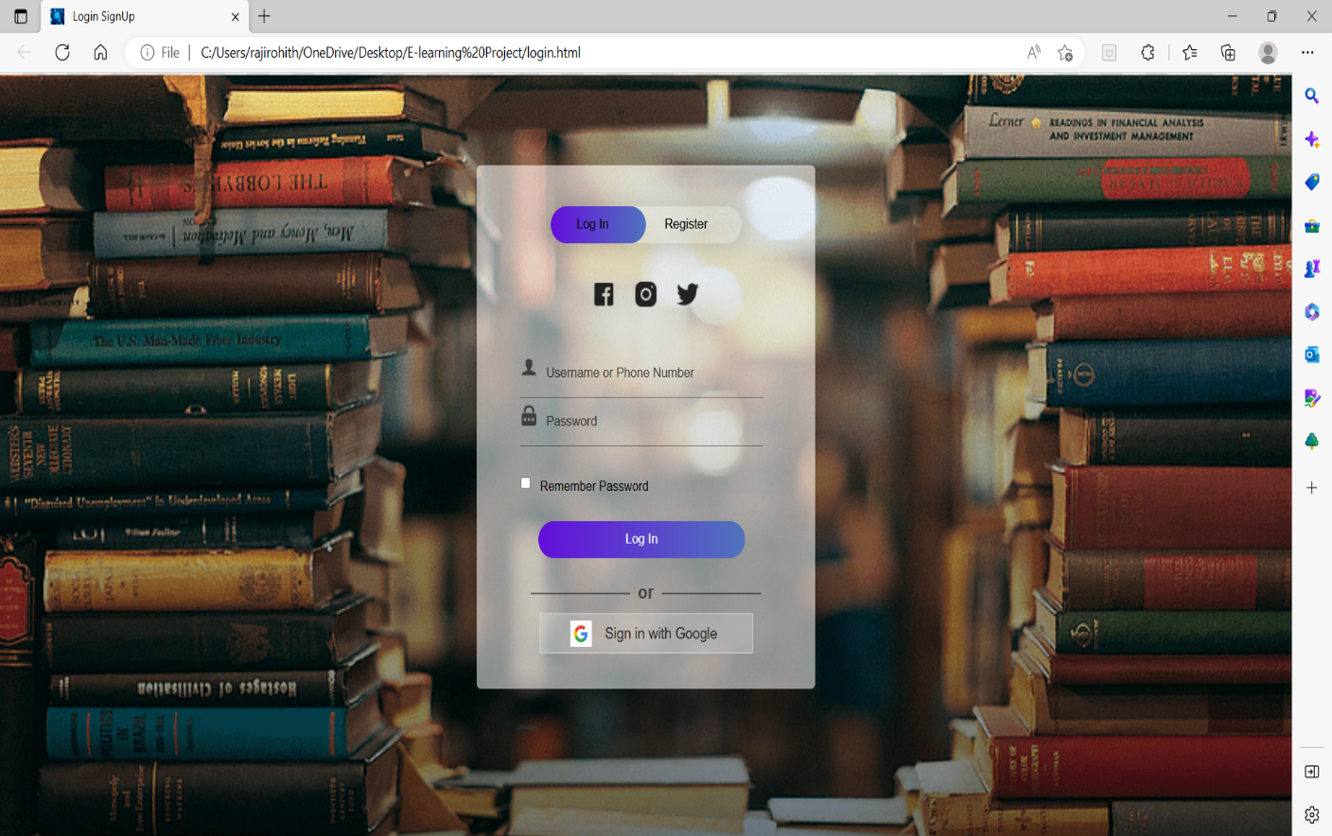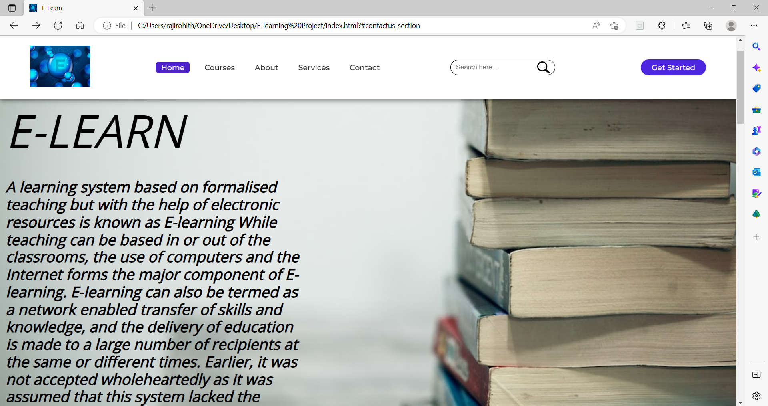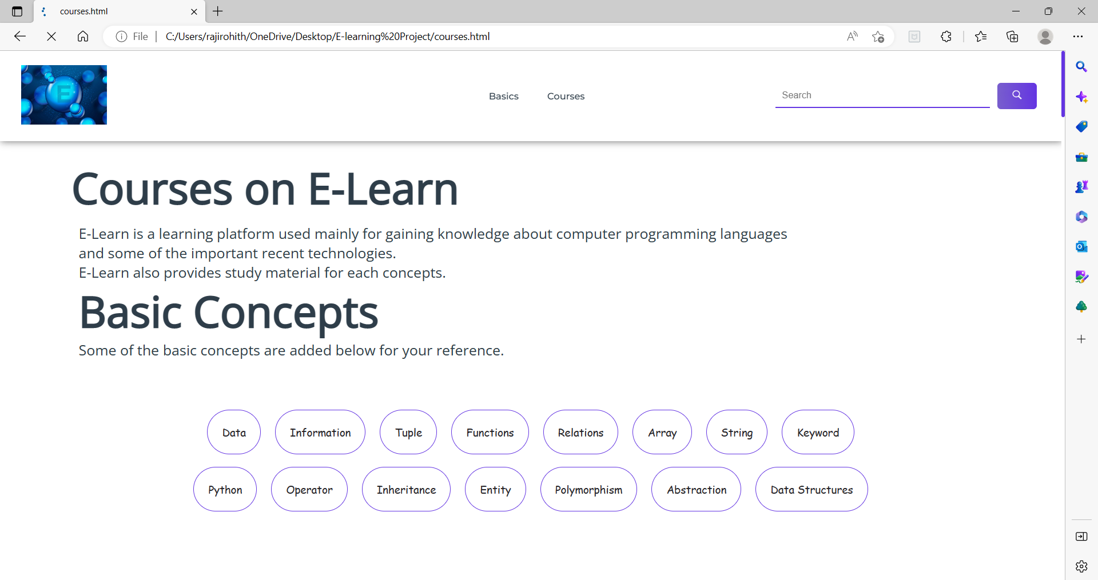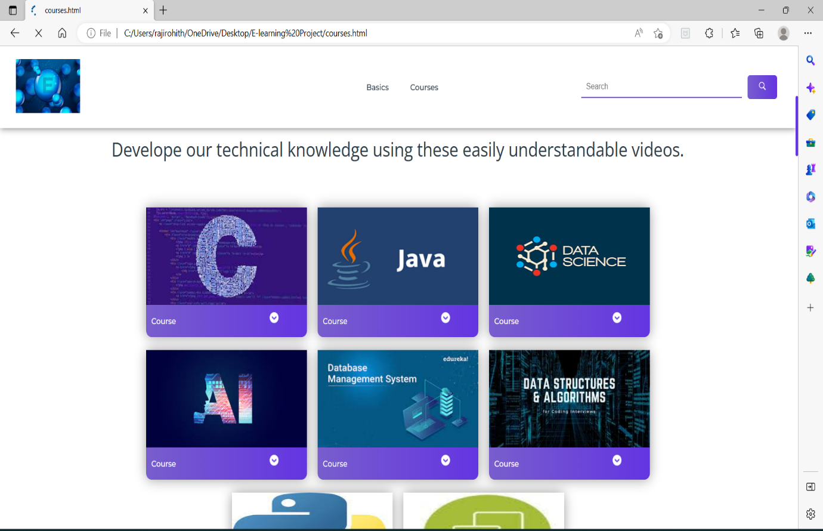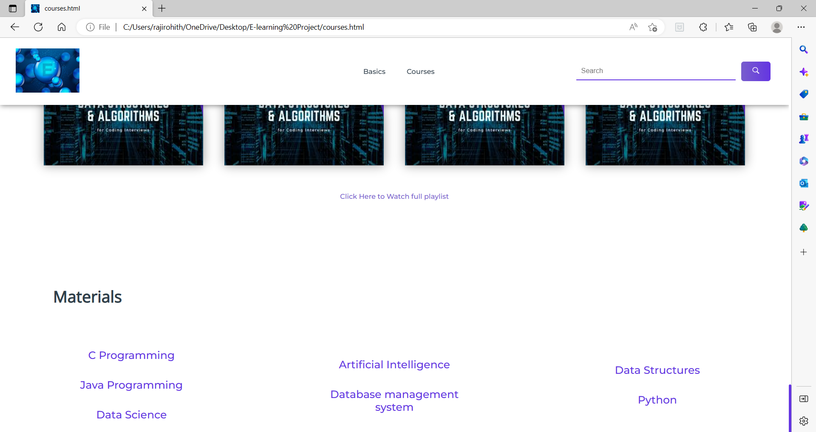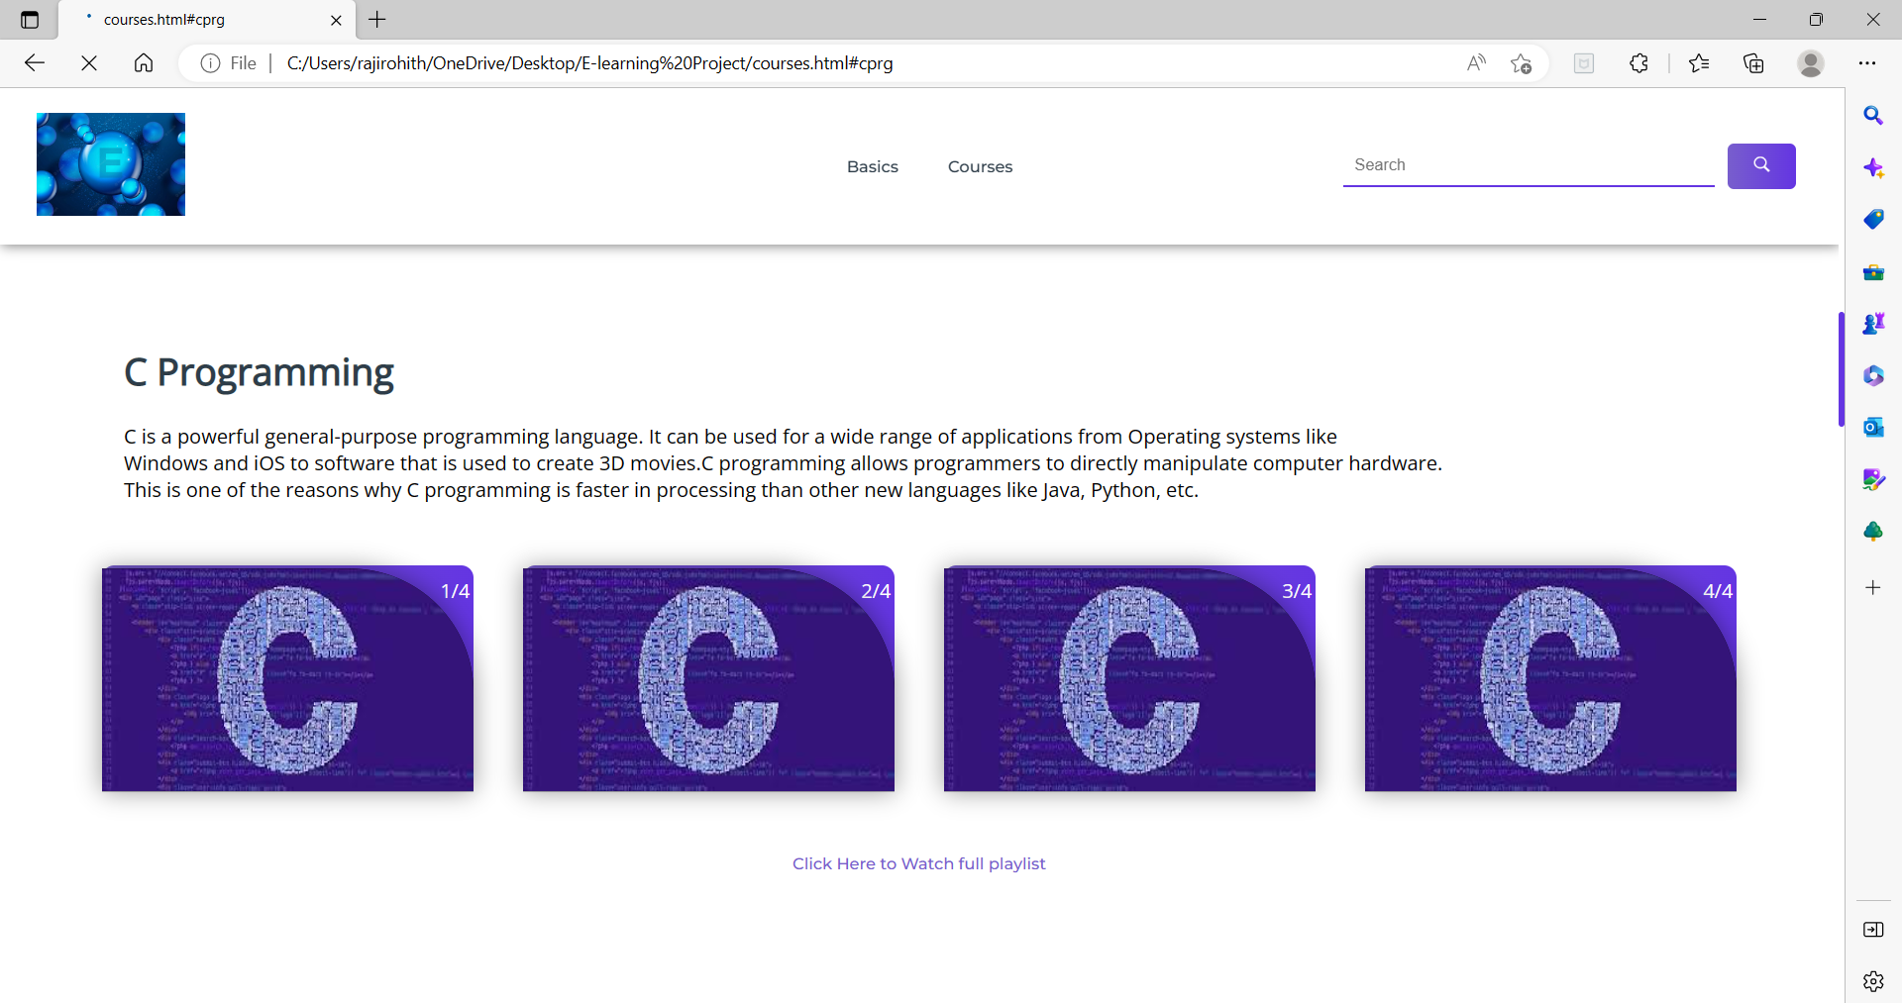

CONCLUSION:

Online learning has gained popularity in the recent past, with many graduates and the working class taking some courses online to enhance their skills.

Technological advancement and the flexibility associated with e-learning have contributed to high satisfaction levels among online students.